**SUBMITTED BY:**

ESHA SADIA NASIR  
 MSCS-2020  
 329594

**DATED:**13-Dec-2020

**SUBMITTED TO:**

DR. MOAZZAM FARAZ

**ASSIGNMENT 2**

**COMPUTER VISION**

**TASK1:  
 Feature Mapping in Images Using Feature Detectors and Descriptors**

1. **ORB:**

**Top 10 Matches found using ORB are as follows:**

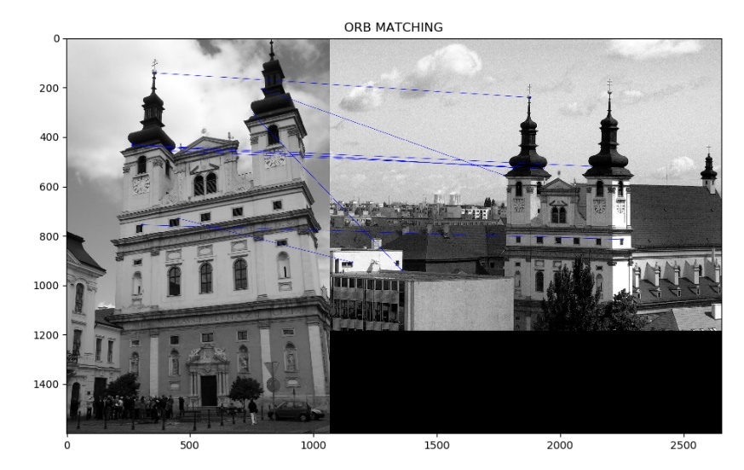

**Feature matching on building with blue marker**

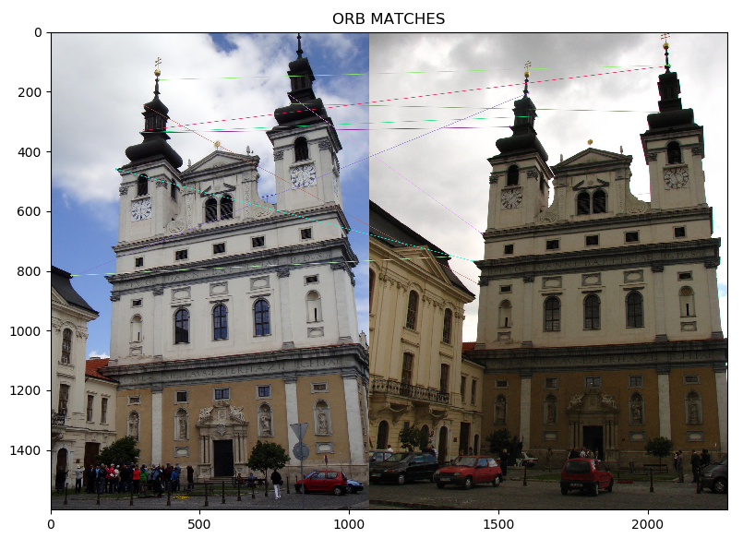

**For building 2 and 3 top 10 matches**

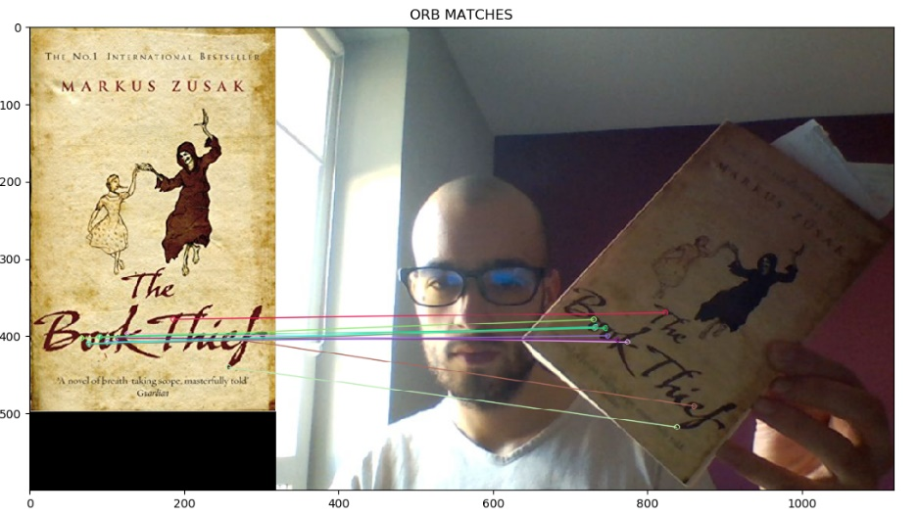

**Top 10 features of book and person holding book**

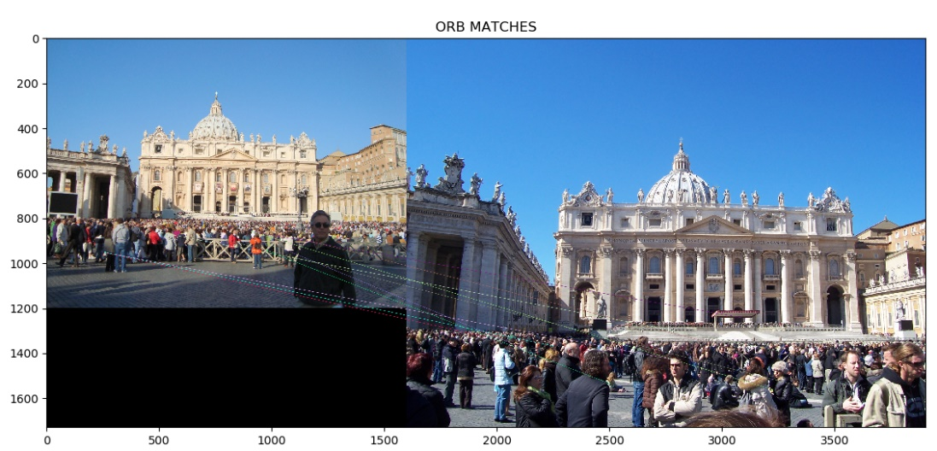

**Matches with green marker for roma1 and roma 2**

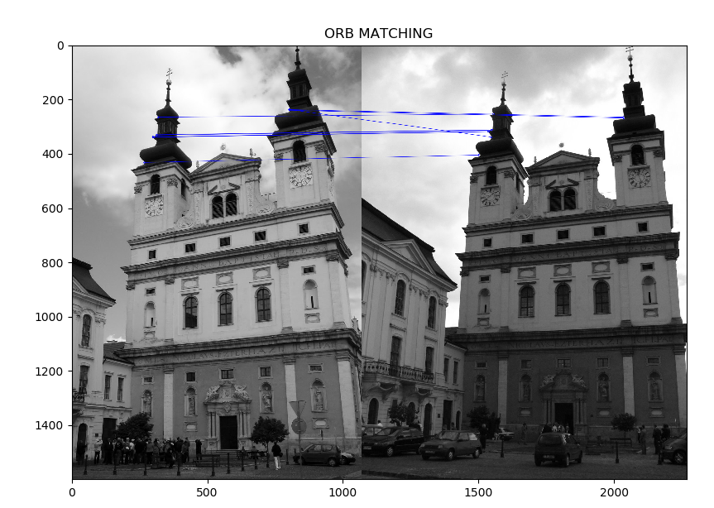

ORB Feature matching in Grascale images

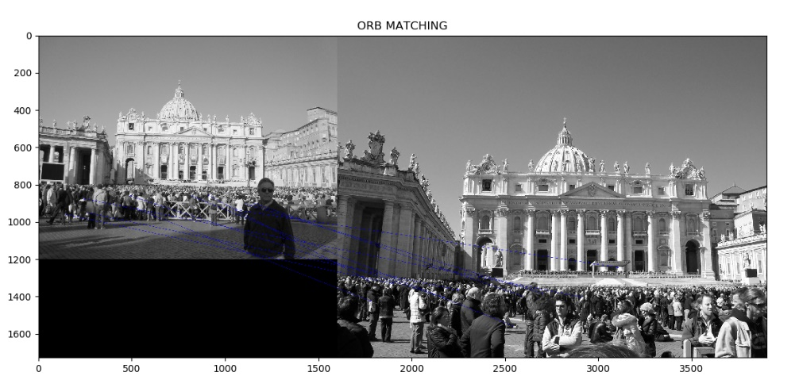

Blue markers reprensting 10 matches of roma

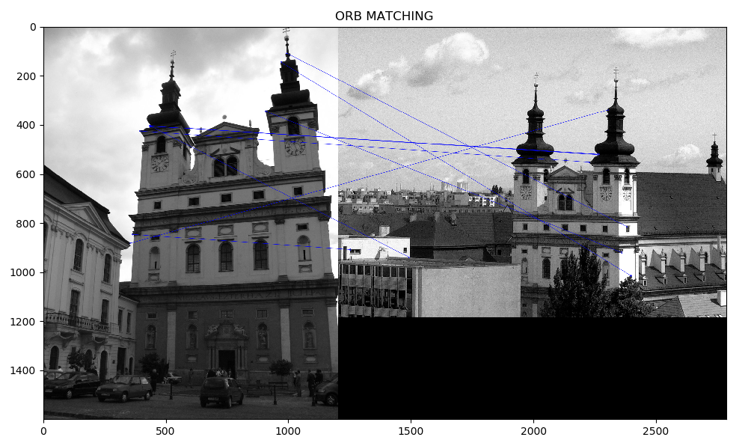

For next 2 buildings feature matches

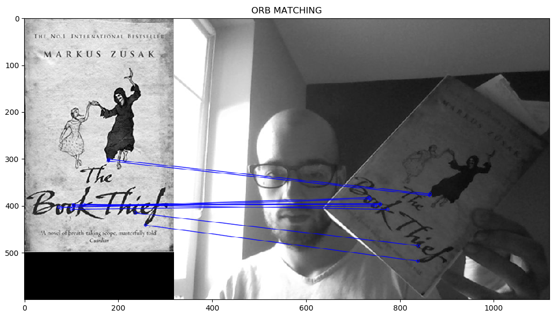

Feature matches for person holding book

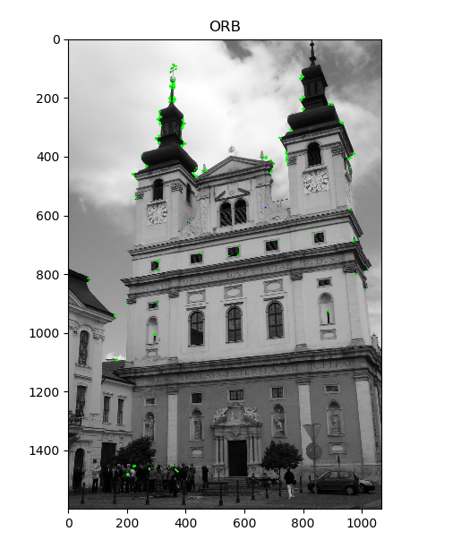

Buidling 2 corners detection without matching

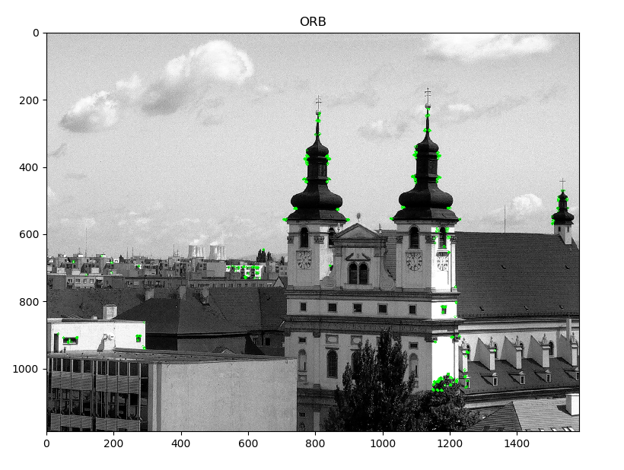

Precise Corner Detected of Buiding 1 Via ORB

import cv2  
from matplotlib import pyplot as plt  
  
# you can use following code to increase or decrease your figure size  
from pylab import rcParams  
rcParams[**'figure.figsize'**] = 5, 5  
  
img = cv2.imread(**'building_2.jpg'**,0)  
img1=cv2.imread(**'building_3.jpg'**,0)  
print(img.shape)  
  
# Initiate ORB detector  
orb = cv2.ORB_create()  
  
# find the keypoints and descriptors with ORB  
kp_orb, des_orb = orb.detectAndCompute(img, None)  
  
kp_orb1, des_orb1 = orb.detectAndCompute(img1, None)  
  
len(kp_orb),len(kp_orb1)  
  
# Match descriptors.  
# create BFMatcher object  
bf = cv2.BFMatcher(cv2.NORM_HAMMING, crossCheck=True)  
matches = bf.match(des_orb,des_orb1)  
  
# Sort them in the order of their distance.  
matches = sorted(matches, key = lambda x:x.distance)  
  
# Draw first 10 matches.  
img3 = cv2.drawMatches(img,kp_orb,img1,kp_orb1,matches[:10],img1, flags=2,matchColor=(0,0,255))  
  
plt.imshow(img3)  
plt.title(**"ORB MATCHING"**)  
plt.show()

1. **SIFT**

**TOP 10 Features Matches of SIFT**

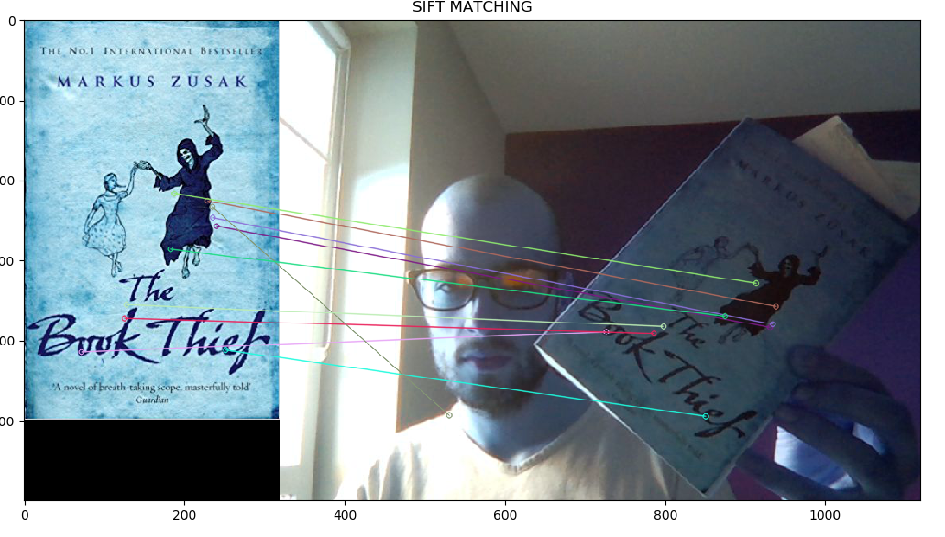

**Sift match for Book and Person Holding book**

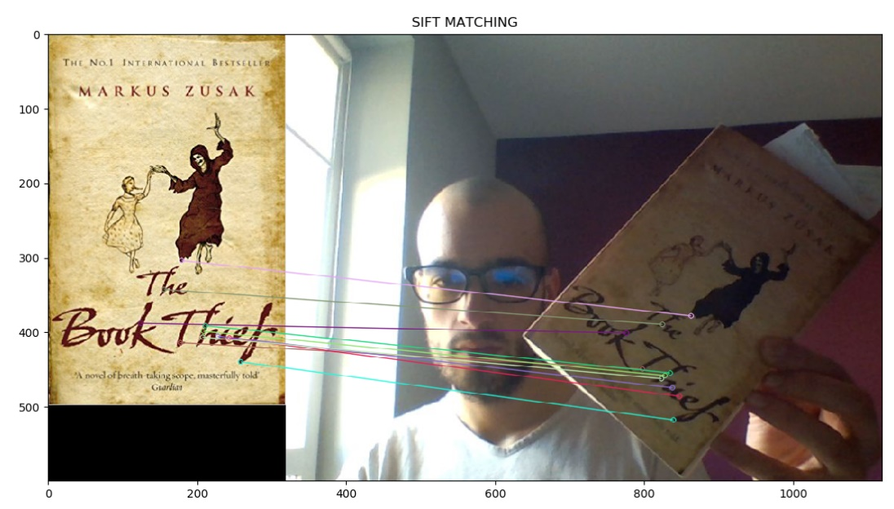

**Sift match for RGB book image and person holding book**

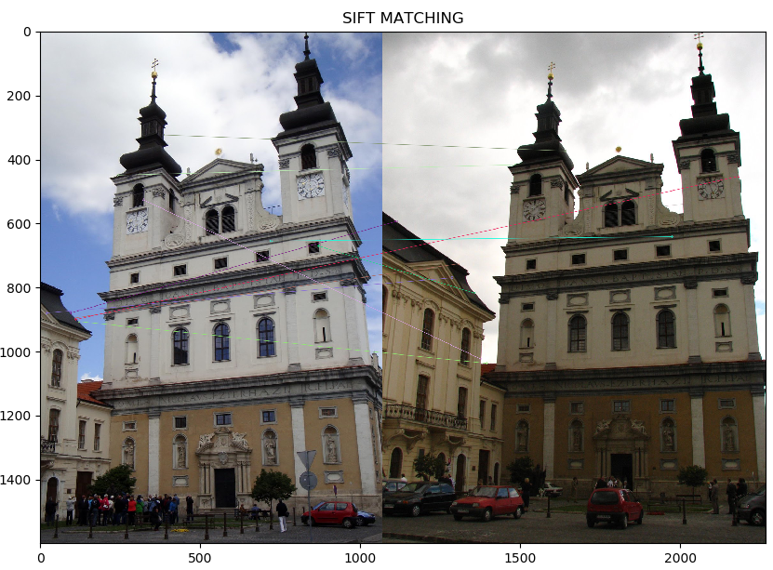

**Feature mapping in two rotated buildings features**

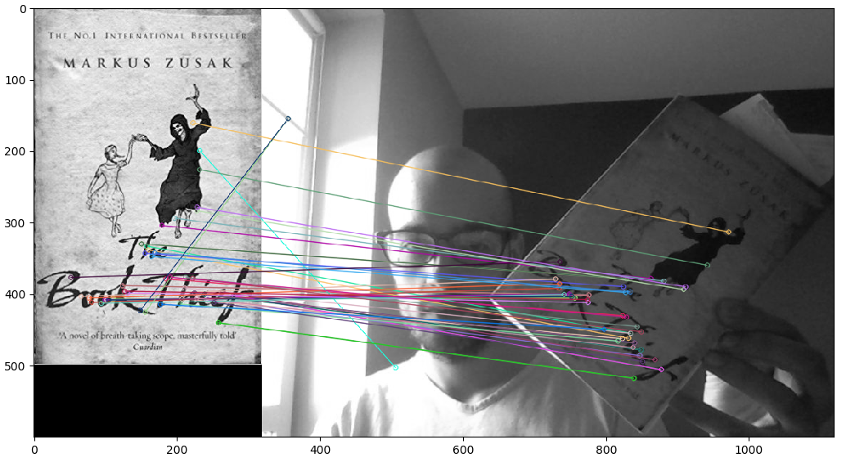

import cv2  
import matplotlib.pyplot as plt  
#matplotlib inline  
#read images  
  
img2=cv2.imread(**'book.jpg'**)  
img3=cv2.imread(**'book_person_holding.jpg'**)  
  
img2=cv2.cvtColor(img2,cv2.COLOR_BGR2GRAY)  
img3=cv2.cvtColor(img3,cv2.COLOR_BGR2GRAY)  
#SIFT  
sift=cv2.xfeatures2d.SIFT_create()  
  
keypoints_2,descriptors_2=sift.detectAndCompute(img2,None)  
keypoints_3,descriptors_3=sift.detectAndCompute(img3,None)  
len(keypoints_2),len(keypoints_3)  
bf=cv2.BFMatcher(cv2.NORM_L1,crossCheck=True)  
matches=bf.match(descriptors_2,descriptors_3)  
matches=sorted(matches,key=lambda x:x.distance)  
img4=cv2.drawMatches(img2,keypoints_2,img3,keypoints_3,matches[:10],img3,flags=2)  
plt.imshow(img4)  
plt.show()

1. **SURF**

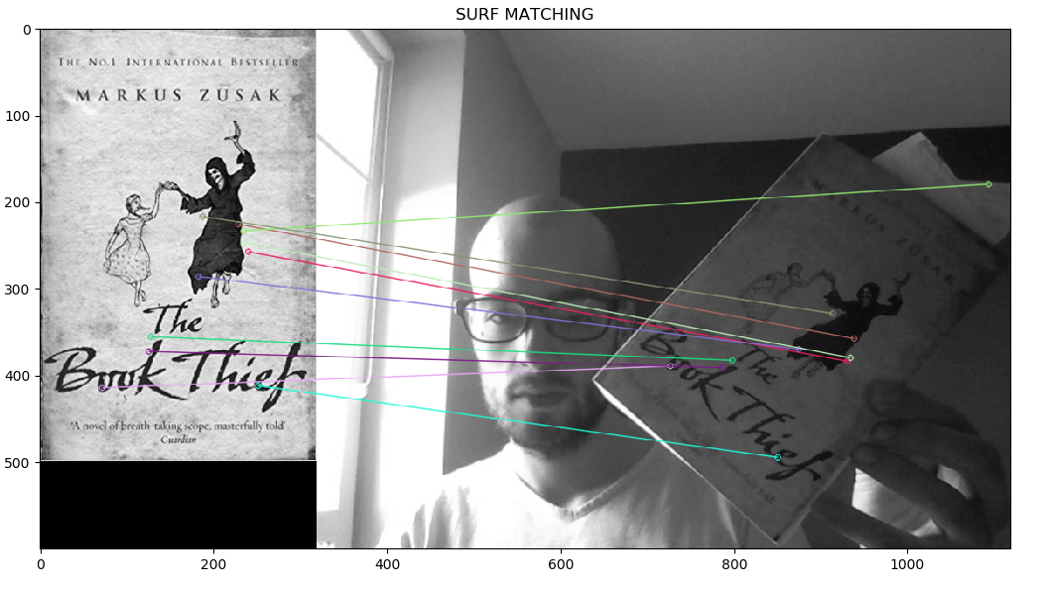

SURF matches for book and person holding book

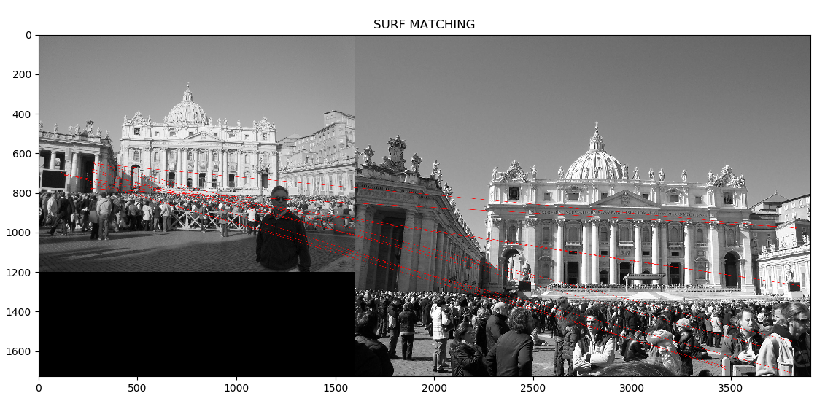

SURF feature Matching for roma images

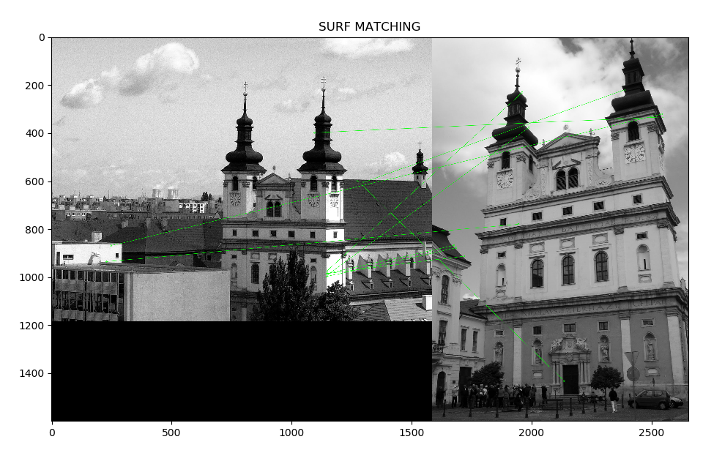

Grayscale images mapping on two buildings

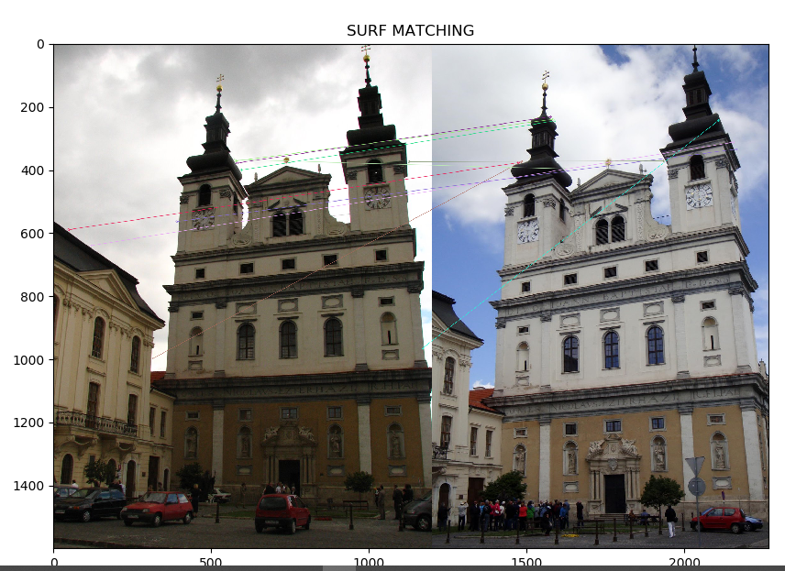

SURF top 10 features for

2 rotated buildings

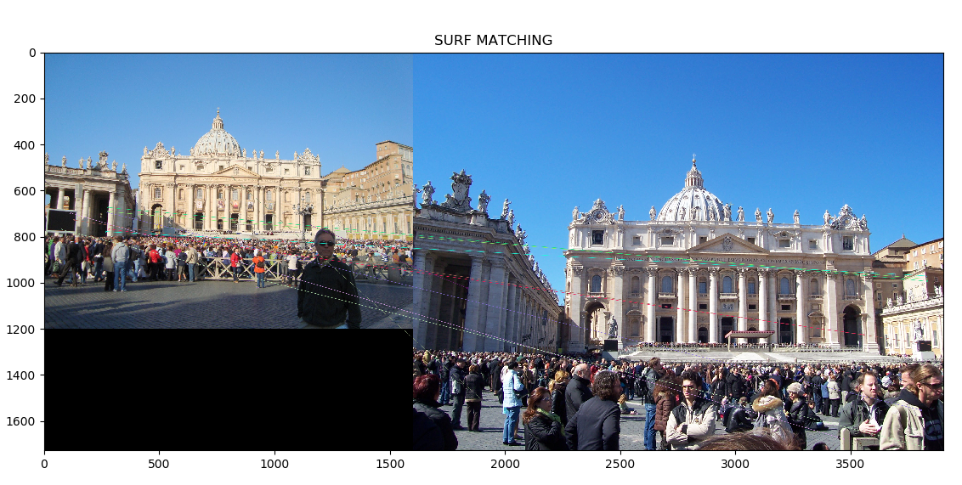

RGB Feature matches for roma buildings

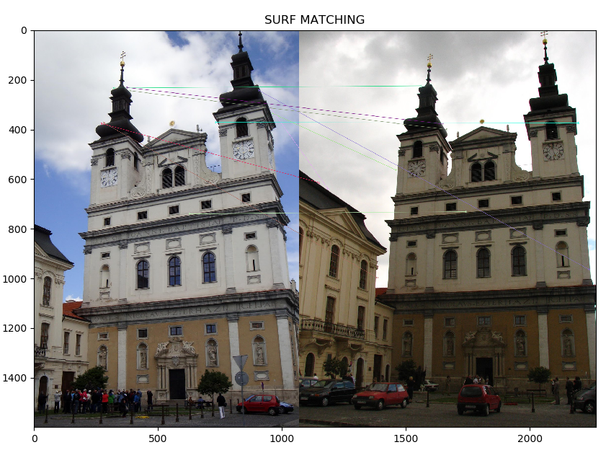

SURF matches for RGB images

import cv2  
import matplotlib.pyplot as plt  
#matplotlib inline  
#read images  
  
img2=cv2.imread(**'book.jpg'**)  
img3=cv2.imread(**'book_person_holding.jpg'**)  
  
img2=cv2.cvtColor(img2,cv2.COLOR_BGR2GRAY)  
img3=cv2.cvtColor(img3,cv2.COLOR_BGR2GRAY)  
#SIFT  
surf=cv2.xfeatures2d.SURF_create()  
  
keypoints_2,descriptors_2=surf.detectAndCompute(img2,None)  
keypoints_3,descriptors_3=surf.detectAndCompute(img3,None)  
len(keypoints_2),len(keypoints_3)  
bf=cv2.BFMatcher(cv2.NORM_L1,crossCheck=True)  
matches=bf.match(descriptors_2,descriptors_3)  
matches=sorted(matches,key=lambda x:x.distance)  
img4=cv2.drawMatches(img2,keypoints_2,img3,keypoints_3,matches[:10],img3,flags=2)  
plt.title(**"SURF MATCHING"**)  
plt.imshow(img4)  
plt.show()

1. **BRIEF**

**Feature Detection Using BRIEF Feature Detector**

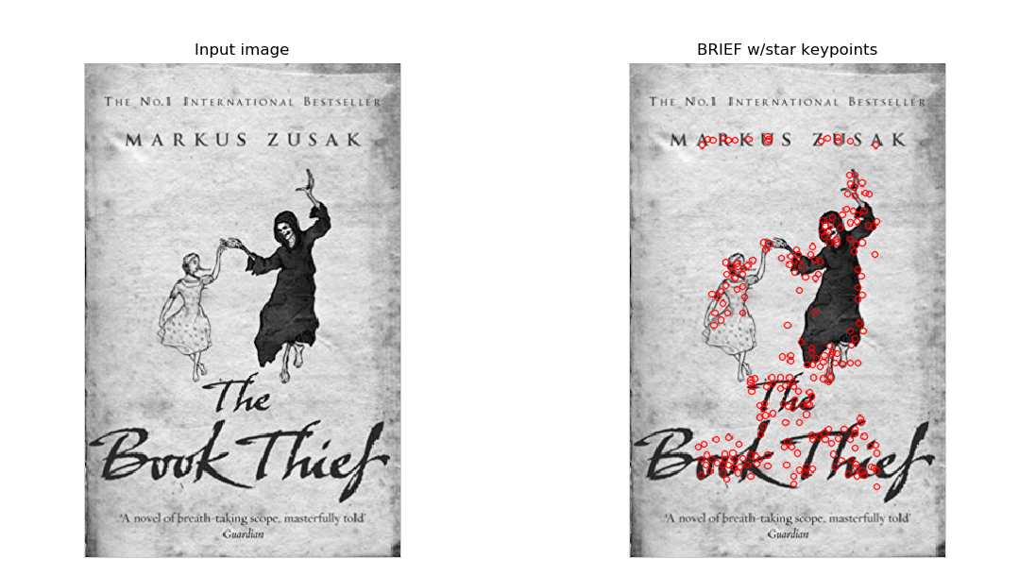

1. **FAST**

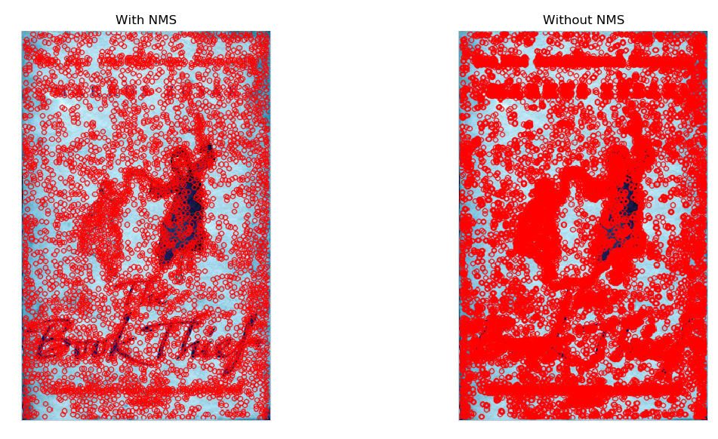 FAST Features detected for book

FAST Features detected for person holding book

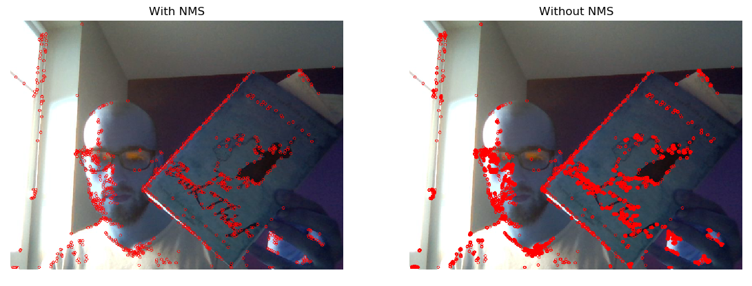

TASK 2:

Results of Few Correctly Classified Images

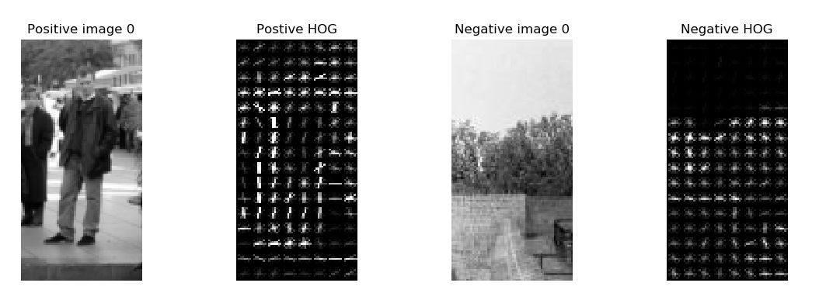

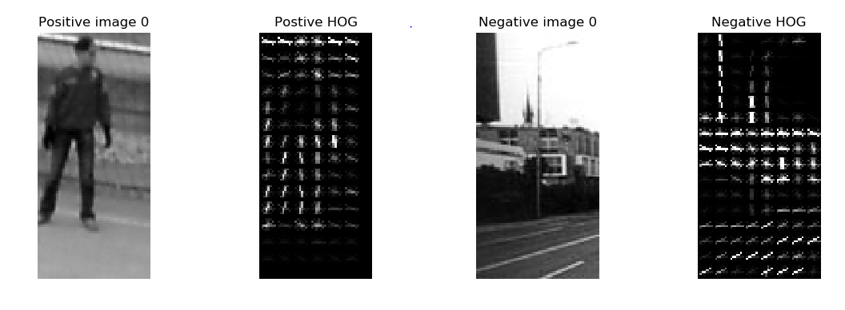

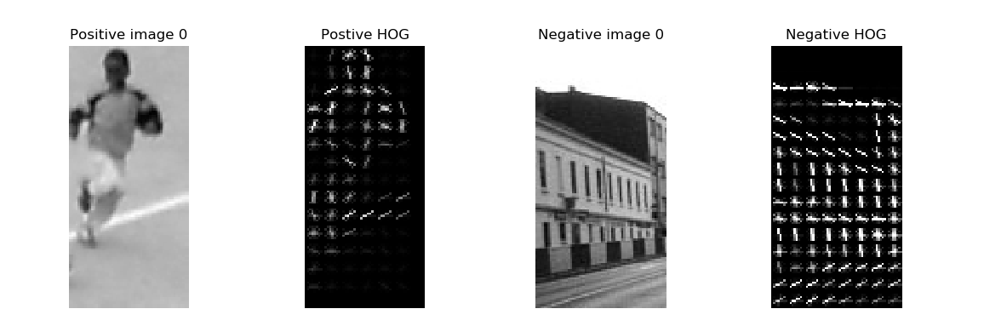

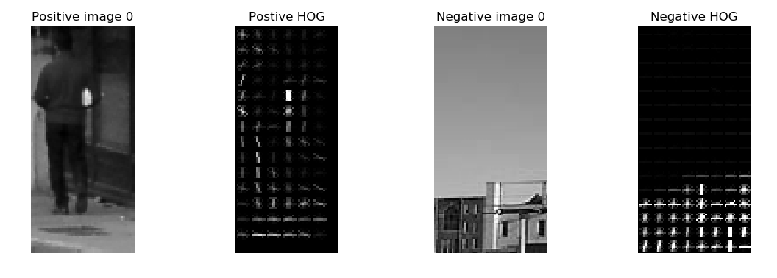

**Quantitative Performance Measures: (Support Vector Machine Classifier)**

* True Positive Rate: **911**
* False Positive Rate: **0**
* True Negative Rate: **2416**
* False Negative Rate: **0**

Accuracy: 1.0

finish learning SVM.

LinearSVC(C=1.0, class_weight=None, dual=True, fit_intercept=True,

intercept_scaling=1, loss='squared_hinge', max_iter=1000,

multi_class='ovr', penalty='l2', random_state=None, tol=0.0001,

verbose=0)  
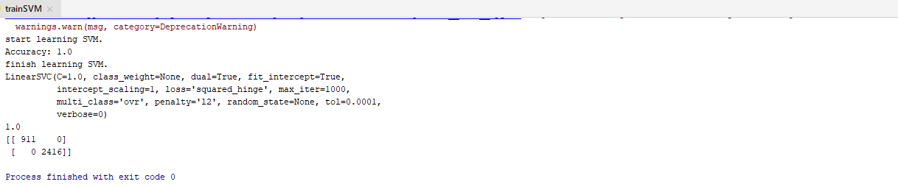

Quantitative Performance Measures: Random Forest Classifier

* True Positive Rate: **909**
* False Positive Rate: **2**
* True Negative Rate: **2412**
* False Negative Rate: **4**

Accuracy: 0.9981965734896303

RandomForestClassifier(bootstrap=True, class_weight=None, criterion='gini',

max_depth=None, max_features='auto', max_leaf_nodes=None,

min_impurity_decrease=0.0, min_impurity_split=None,

min_samples_leaf=1, min_samples_split=2,

min_weight_fraction_leaf=0.0, n_estimators=10,

n_jobs=None, oob_score=False, random_state=0, verbose=0,

warm_start=False)

